# CHASE BASKETBALL

# First Aid Policy

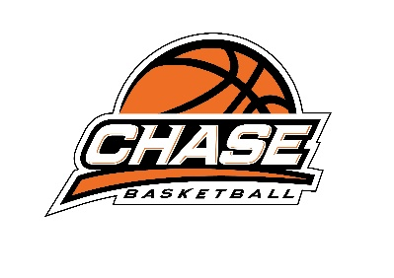**Purpose**  
In an emergency situation first aid aims to maintain life, prevent further harm / injury, ease pain and prevent deterioration of the person's condition until professional medical help can be obtained.  
  
To provide immediate care to an injured or ill person, carried out within a limited range of skills, until the injury or illness is managed or a higher level of care presents such as: a doctor, a paramedic, or a nurse.  
   
**Policy**  
CHASE BASKETALL is committed to providing timely and appropriate first aid care to coaches, players/students. CHASE BASKETBALL will endeavour to have a suitable number of trained first aid coaches on staff for each program/site and provide first aid equipment to administer appropriate and adequate first aid treatment in the event of a person sustaining an injury or illness. 

**Procedure**   
The First Aid Audit must be completed bi-annually:

* External Training will be provided for all Chase Basketball coaches. Chase Basketball Head Coaches MUST be first aid trained and show evidence of completion of first aid course.
* Chase Basketball staff will also attend training for certification
* If injured or ill person is involved in school Academy classes, the coach will determine whether the student needs to be escorted to the school first aid officer and parent contacted.
* Once the injured or ill person has been assisted, coaches will complete an incident report for the HR/program manager.
* Once the injured or ill person has been assisted, HR/program manager to contact relevant parent/guardian with incident report details.
* All incident reports will be filed in the incident register for incidents or injuries,
* Data will be reviewed on a regular basis to ensure there are no trends in injuries that need to be minimised.

**First Aid Kits**  
Should any first aid equipment be used from first aid kit, coaches to notify management of replacement stock requirements. Chase Basketball First Aid Kits are reviewed and restocked regularly.  
  

**Responsibility**   
It is the responsibility of senior Chase Basketball manager/s to ensure that:

* Adequate and appropriate First Aid equipment is available for use at every Chase Basketball session/program/venue
* Appropriate and adequate First Aid Officers training is arranged for staff.
* First Aid Officers’ training is up to date and coach certificates are current and recorded.

It is the responsibility of all Chase Basketball coaches in charge of Chase Basketball sessions to:

* Assess if medical assistance is required.
* Administer appropriate First Aid in accordance with their training.
* Maintain First Aid records as outlined in this procedure.
* Maintain confidentiality with regard to information obtained as part of their role.

 It is the responsibility of senior Chase Basketball management to:

* A logo of a basketball

  AI-generated content may be incorrect.Inspect and maintain First Aid equipment