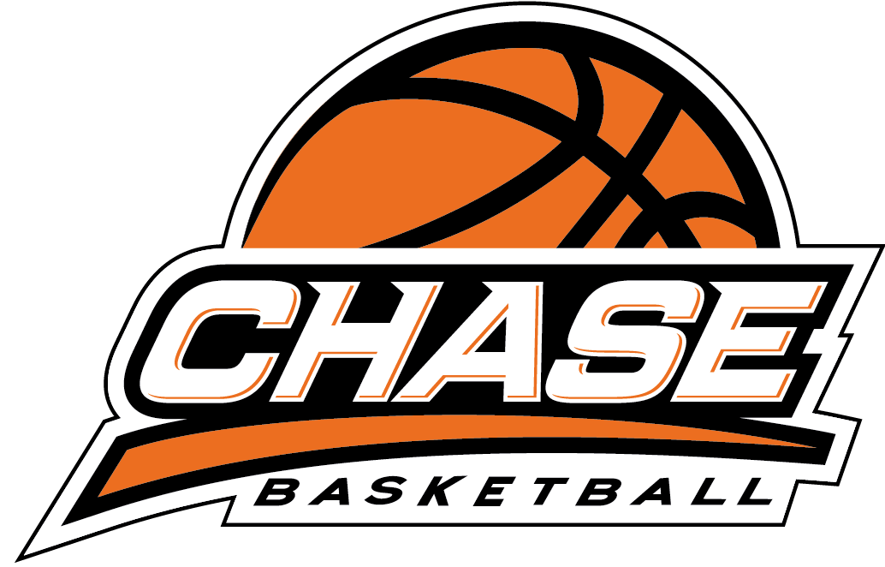

CHASE BASKETBALL
NUT-FREE POLICY

As part of ongoing safety awareness at CHASE Basketball programs, we ask parents to be mindful of any products containing nuts when preparing lunches or snacks for their children.

Whilst CHASE Basketball programs encourage a nut free environment, as they are conducted in public facilities, CHASE Basketball Programs are NOT totally nut free events.

Parents of children who have suffered any anaphylactic reaction to any foods or insect bites, need to provide CHASE Basketball administration with an up-to-date medical action plan, signed by their treating doctor, before their child can participate in CHASE Basketball activities.

CHASE Basketball staff are trained in First Aid Management of Anaphylaxis

