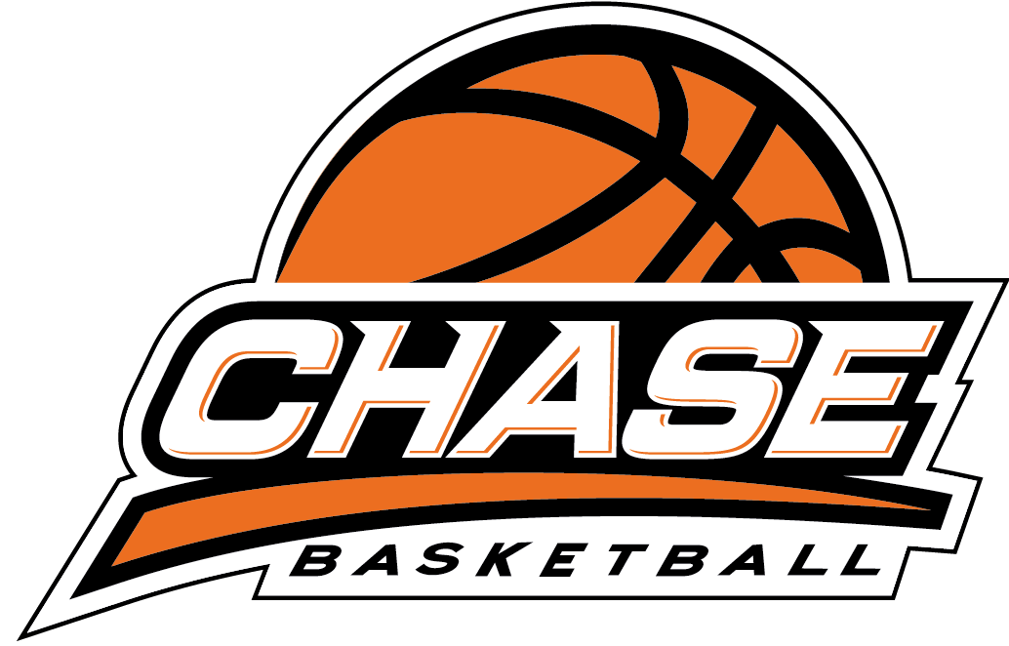

COMMITMENT TO CHILD SAFETY AND PROTECTION
Chase Basketball has a commitment to child safety and wellbeing through all levels of its programs and for all participants. Through inclusive and accessible opportunities, it acknowledges the importance of providing culturally safe environments and practices for Aboriginal and Torres Strait Islander children and young people and to keeping all children safe from abuse and harm.

What is child abuse?
Child abuse is any physical or emotional ill treatment by someone in a position of responsibility, trust or power that harms or could harm a child’s health, survival, development, or dignity.

Indicators of child abuse can include but are not limited to inconsistent or absent explanation of bruising, unexplained absences, lack of trust of adults, anxiety, or withdrawal. Chase Basketball coaches and staff are expected to put any indicators in context and report concerns to management and/or appropriate child protection services.

Reporting
Any suspicion of child abuse or neglect either by a coach or staff member or about a coach or staff member should be reported through the appropriate channels, so that Chase Basketball management can escalate to the relevant child protection authorities admin@chasebasketball.com.au. All reports are treated with the highest level of privacy and sensitivity.
Cultural, gender and ability diversity
The cultural, gender and ability needs of all participants and staff will be met as required to ensure that participation in Chase Basketball programs is not compromised. Where possible, the cultural and linguistic needs of children will be addressed in all communications to ensure appropriate levels of understanding and messaging.

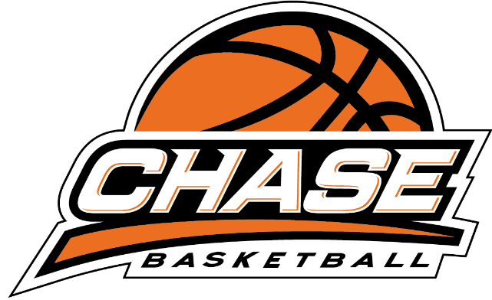

COMMITMENT TO CHILD SAFETY AND PROTECTION
What will Chase Basketball management and staff do to maintain the highest child protection standards?
All Chase Basketball programs have the highest level of coach and staff screening, training, and monitoring with prevention and reporting processes that ensure children’s safety.
Chase Basketball adheres and refers to the Basketball Victoria Child Safe Standards.
https://www.basketballvictoria.com.au/resources/child-safe-standards
Chase Basketball coaches and staff maintain annual first aid training, basketball coaching qualifications and ongoing LGBTQIA+ and cultural awareness training.
Every Chase Basketball program provides a safe and inclusive environment for all participants, coaches, staff, and families that is under the scrutiny of ongoing monitoring and regulation.
What can you do to maintain the highest child protection standards?
If you receive a report or believe that you have seen indicators of child abuse within a Chase Basketball program, you should inform a Chase Basketball coach, staff member or management personnel immediately.
If you need any information on Chase Basketball programs, policies or processes please contact www.chasebasketball.com.au, admin@chasebasketball.com.au or mobile 0492 938 010

For more information on Victorian Government or Basketball Victoria guidelines you can access the below links:

https://services.dffh.vic.gov.au/child-protection-contacts
https://www.basketballvictoria.com.au/resources/association-resources/child-safe-standards

